**NAME:______________Eric Somogyi______________________**

# Activeresponnetstat Directory Attacks (Lab #5)

# 75 Points

# Net-NTLM cracking

1. Return to the Kali box. You should see a captured NTLM-v2 response. Take a complete screenshot of this response as well as the poisoned answer responded to including the entire hash. (an example of both are shown below)

**Answer:**

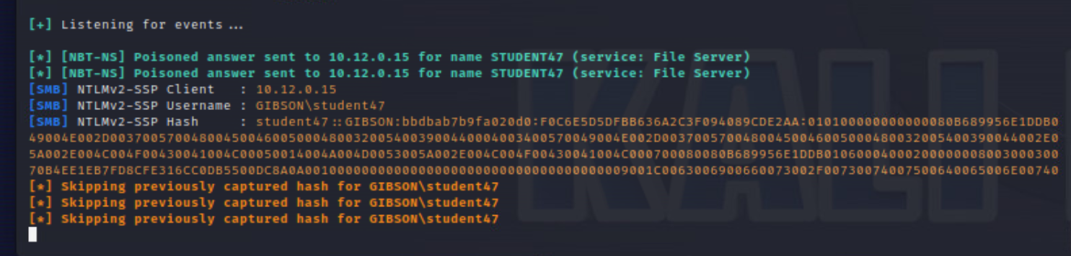

1. You should see a status of cracked after a minute or so. Take a screenshot showing this status as well as the cracked password.
2. **Include screenshots asked for above. What type of hash did you crack? Explain what options were used in the hashcat command used. (15 pts)**

**Answer:**

**I cracked a blank hash.**

**The option that were used in the hashcat command mean the following:**

**Hashcat: initiates the hashcat tool**

**-m: This indicates the option of “hash-type”, which is a precursor to the category reference for “NetNTLMv2”**

**5600: This indicates the name of the hash mode, which is “NetNTLMv2”**

**-a: This indicates the option of “attack-mode”, which is the precursor to “0”**

**0: This indicates the Attack Mode is “Straight”**

**Hashes.txt: This indiciates the “hash|hashfile|hccapxfile”**

**/usr/share/wordlists/wfuzz/general/medium.txt: This indicates the (dictionary or mask or directory) for the cache hit. This path is considered a dictionary.**

**See Screenshot below**

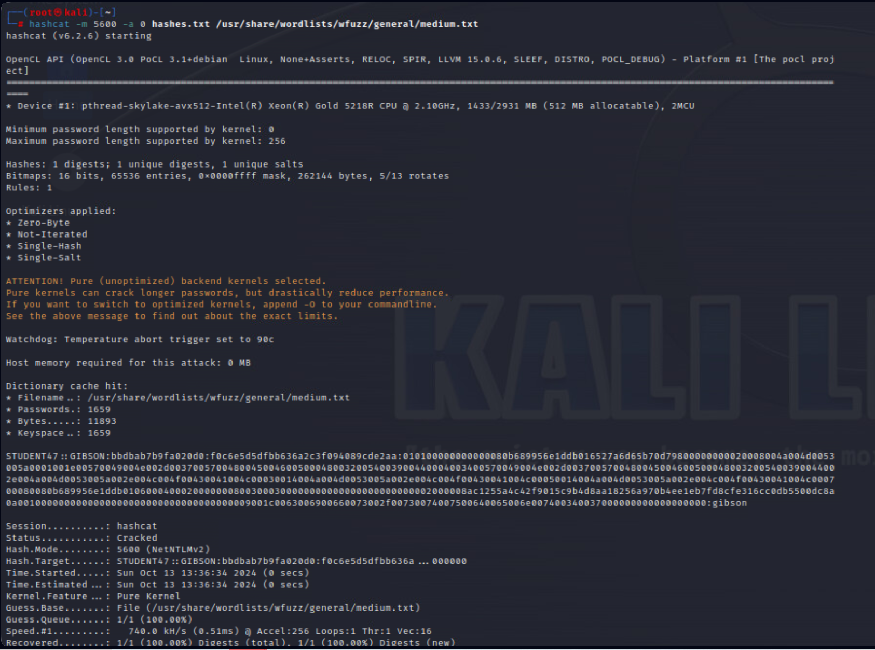

# Golden Ticket

1. Run whomi to confirm you are running with user privileges. Attempt to visit the c$ share on the domain controller by running ipconfig && date /t && time /t && whoami && pushd \\gibson2003ad\c$. Take a screenshot showing the output of all the previous commands. You should get an access denied message. Why do you think that is?

**Answer:**

**I’m getting the access denied message because since I’m logged in as a non-administrator on the Windows 10pc while the pushd command is trying to change my current directory to the Gibson2003AD PC share directory, I do not have the proper administrative privileges to do so, which is why Access is Denied.**

**See Screenshot below (the screenshot with command and Access is Denied result wouldn’t fit in 1 screenshot so I had to take a 2nd one FYI).**

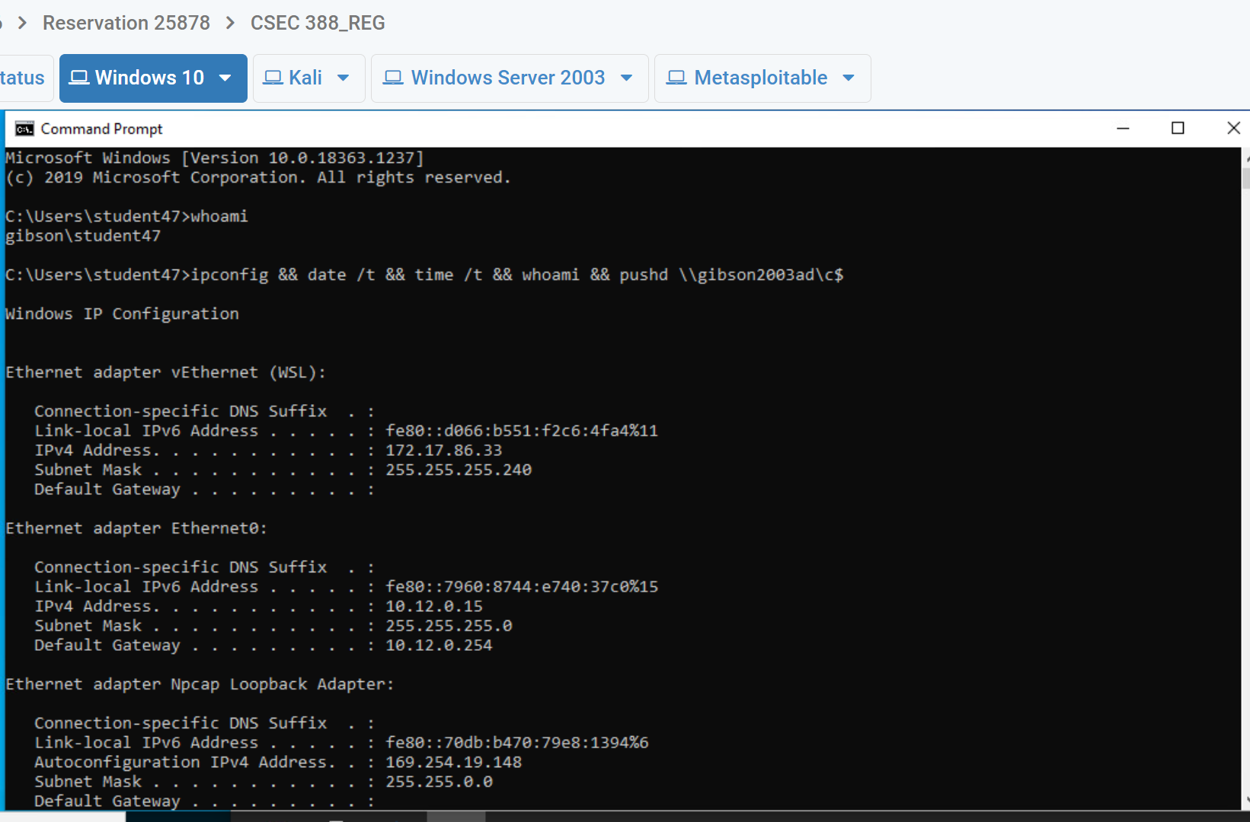

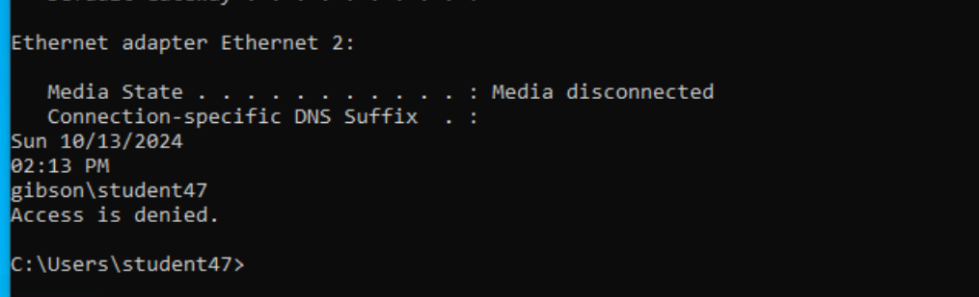

1. Create a golden ticket using mimikatz and inject the golden ticket using pass the ticket. Take a screenshot of your command used and the output.
   1. Command Example (this will not work as written): kerberos::golden /admin:*Bob* /domain:*c137.local* /sid:*S-1-1-12-123456789-1234567890-123456789* /krbtgt:*deadbeefboobbabe003133700009999* /ticket:Administrator.kiribi /ptt
      1. /admin = domain admin from step #4
      2. /sid = SID from step #4 step 5
      3. /krbtgt = krbtgt NTLM hash from lab 4 domain controller hashdump (secretsdump output)

**Answer: See screenshot below**

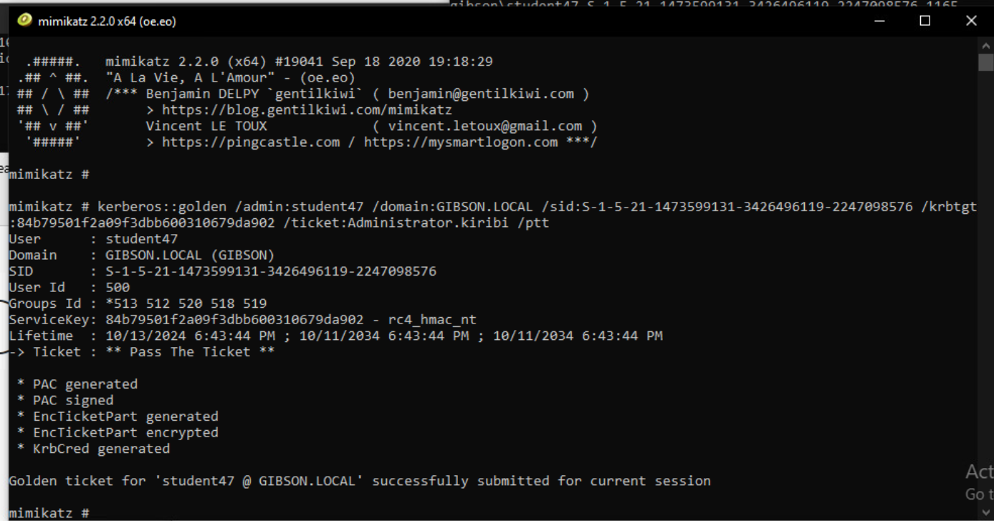

1. Run ipconfig && date /t && time /t && whoami && pushd \\gibson2003ad\c$ && dir and take a screenshot. List the contents of the directory and take a screenshot.

**Answer: See 2 screenshots below.**

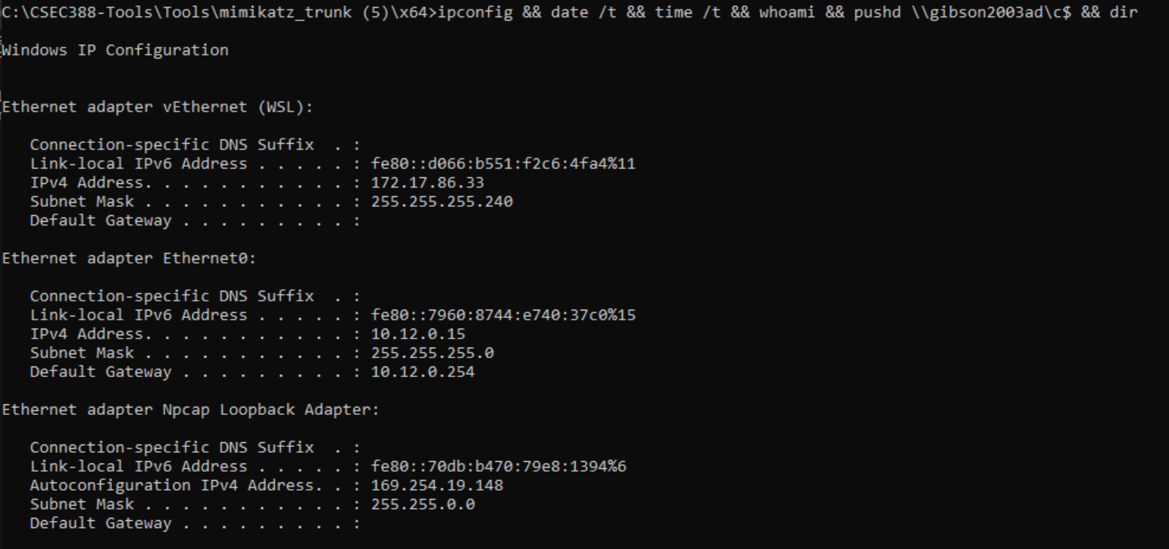

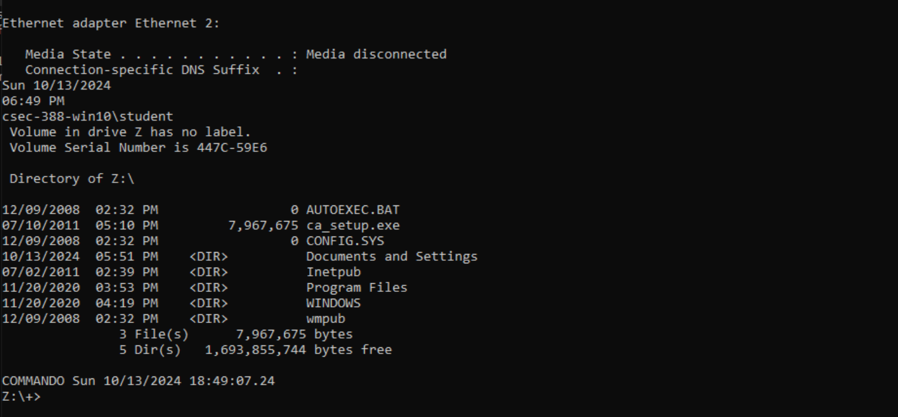

**This screenshot too just in case.**

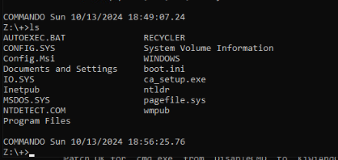

1. Return to the cmd shell from step 1 (run as the account user) and run klist. This will show your current Kerberos tickets.
2. **Include screenshots asked for above.** **Do you see your newly generated ticket from step 8 in step 10 and step 12? If not, why don’t you? Do you think it is a good idea to impersonate a member of the Domain Admins group? Why? (15 pts)**

**Answer:**

**Yes. I see the 3 matching Kerberos tickets. Ticket #0 is Ticket Flag:0x60a00000, Ticket #1 in the Administrator cmd window is Ticket Flag:0x40e00000 which matches Ticket Flag #1 in the Student cmd window, Ticket Flag #2 in the Administrator cmd window is Ticket Flag:0x40a40000 which matches Ticket Flag #2, #3, and #4 in the Student cmd window. This is 3 of these same tickets in the Student cmd window for the 3rd and last Ticket #2 in the Administrator cmd cindow. As seen in the screenshot below, there are only 3 tickets on the Administrator cmd side window while the Student window has 5 tickets.**

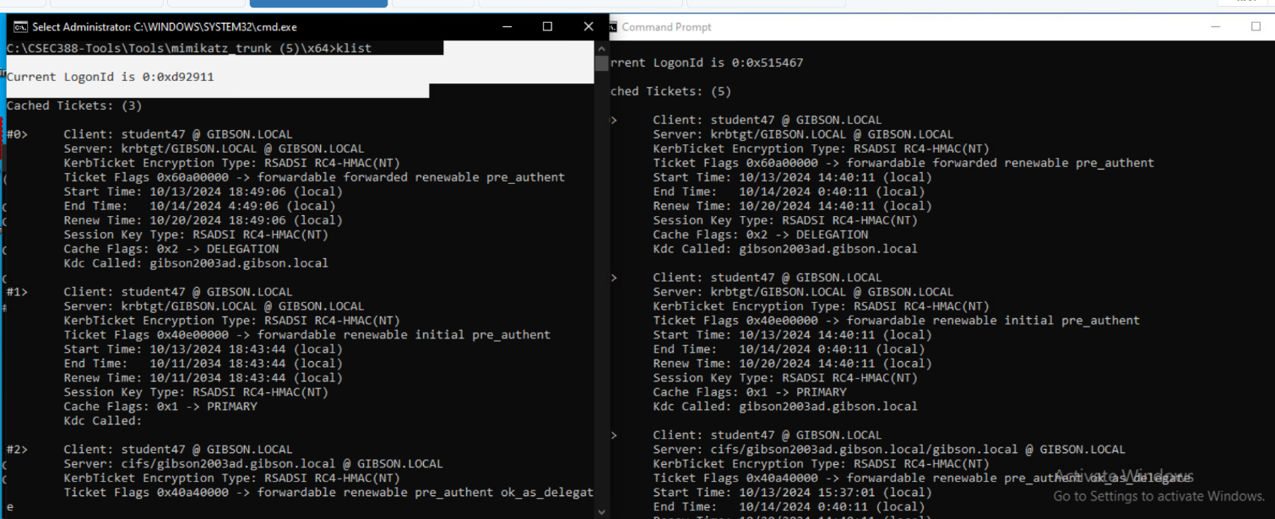

**(this screenshot is the remaining portion of the right side cmd Student window)**

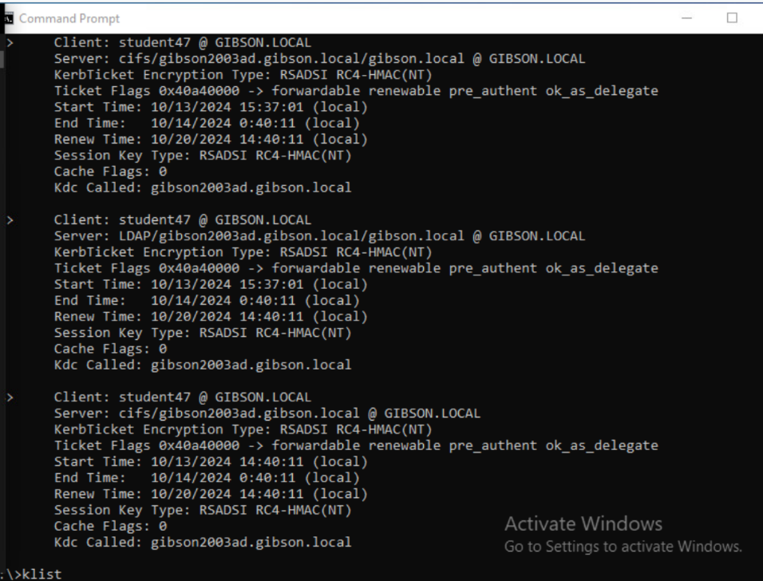

**It is a bad idea to impersonate members of the Domain Admins Group because the Domain admins can modify anything within the AD domain. If an attacker takes advantage of this access, they could compromise the network because of having access to sensitive data. This Golden Ticket basically enables the attacker to maintain access to the Domain Administrator for long periods(up to 10 years) since their Golden ticket doesn’t expire for that long by default.**

# Pass the Hash

1. Open up cmd and attempt to visit the c$ share on the domain controller by running ipconfig && date /t && time /t && whoami && pushd \\gibson2003ad\c$ to ensure that you no longer have access. Take a screenshot.

**Answer: See screenshot below**

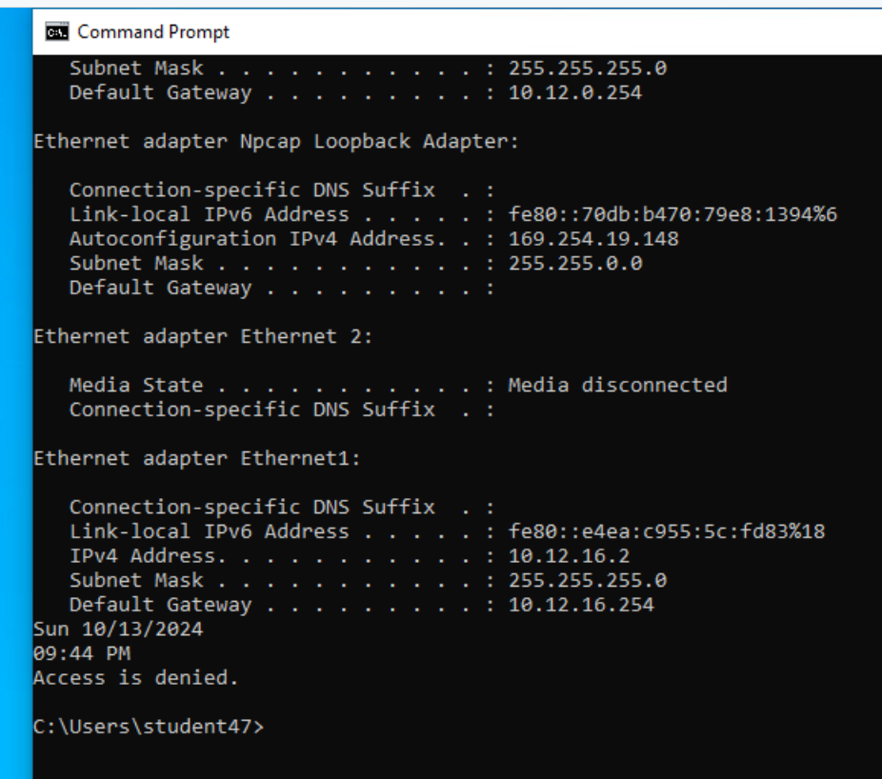

1. Pass the hash using mimikatz. Take a screenshot of the command used and output.
   1. Elevate privileges: privilege::debug
   2. Command Example (this will not work as written): sekurlsa::pth /user:adminStudent*[your_student_#]* /domain:*c137.local* --/ntlm:*cc126155b0b1b31a4fa2b55e2f0aa790*

**Answer:**

**Cmd I used:**

**sekurlsa::pth /user:adminStudent47 /domain:GIBSON.LOCAL /ntlm:a7f7a9298c0048c65022860099309159 *-– just in case see first white screenshot from password hash I got to work during this lab**

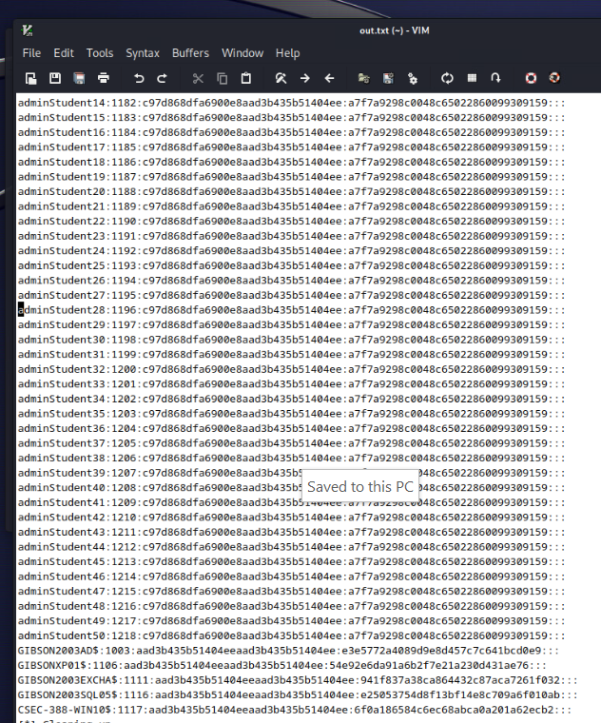

**See Screenshots below**

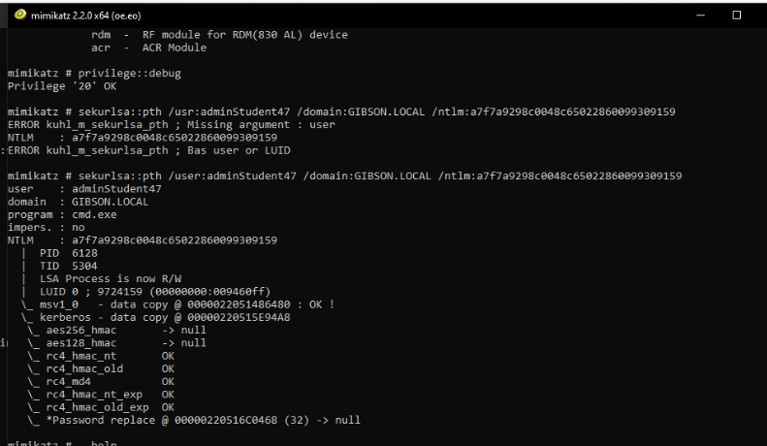

1. A new cmd shell will open automatically. Run ipconfig && date /t && time /t && whoami && pushd \\gibson2003ad\c$ && dir and take a screenshot.
2. **Include screenshots asked for above. Why do you think this attack works without a user password? (15 pts)**

**Answer:**

**This attack works without a user password because my current session is using the hash for the authentication.**

**Another possibility is I logged into the other Windows account and already have cached the data/credentials for** **\\gibson2003ad** **by using my adminStudent47 password:gibson login.**

**Another possibility is gibson is the same password for student47 on the gibson domain on the Windows 10 and is also the password for adminStudent47 on the 2003 AD.**

**Another possibility could be that since they are all shared on the same Windows domain, the hash data has been stored.**

**See screenshots below**

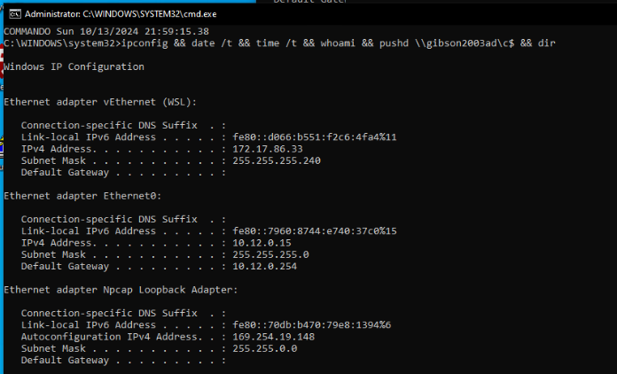

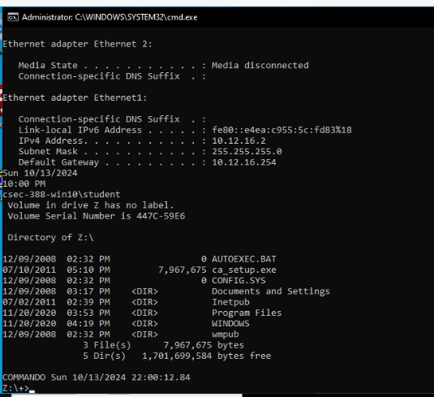

# MS14-068

1. Open up cmd and attempt to visit the c$ share on the domain controller by running ipconfig && date /t && time /t && whoami && pushd \\gibson2003ad\c$ to ensure that you no longer have access. Take a screenshot.

**Answer: See screenshot below**

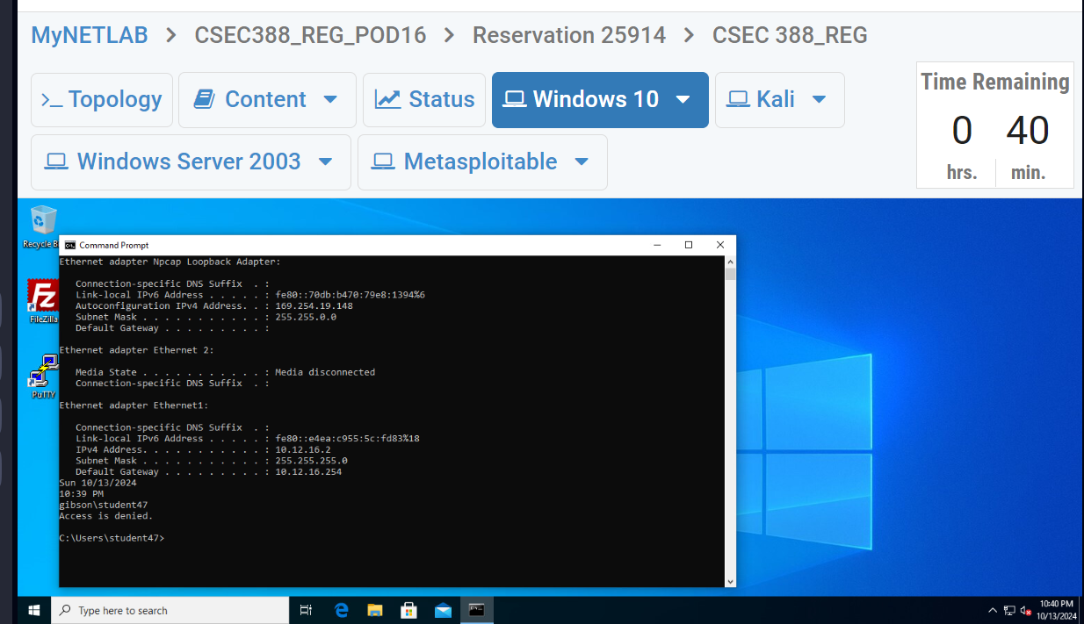

1. Navigate to the CSEC388-Tools folder. Using cmd, run the ms14-068.exe. Fill in the options using the student user and other information you gathered. This will modify our existing TGT to give us added permissions and save it to the local directory. Take a screenshot of your command and the generated ticket file (the output of the command).

*Note: You will need the full student# user SID. You should also use domain names, not IP addresses.*

**Answer: See screenshot below**

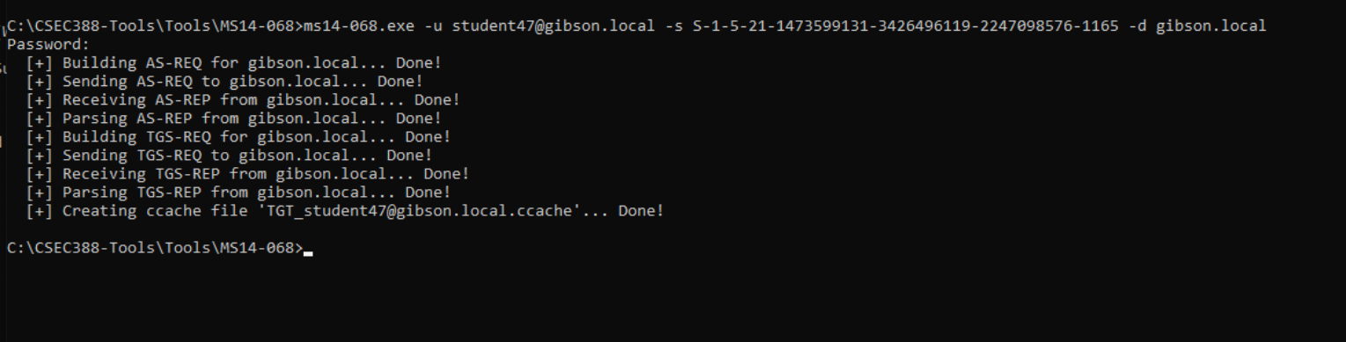

1. MS14-068 using mimikatz. Take a screenshot of your successful injection of the forged ticket.
2. Clear old Kerberos tickets: kerberos::purge
3. Inject ticket: kerberos::ptc *path_to_*.ccache

**Answer: See screenshot below**

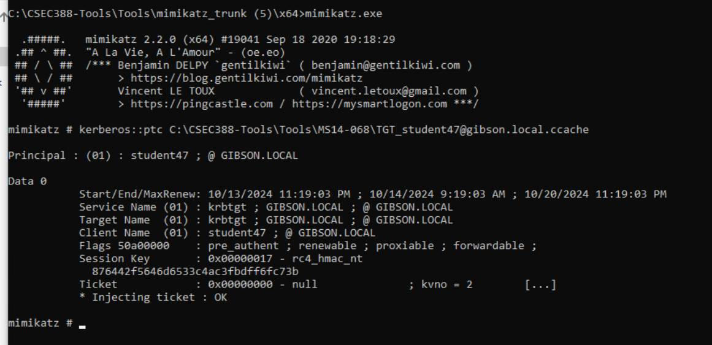

1. Run ipconfig && date /t && time /t && whoami && pushd \\gibson2003ad\c$ && dir and take a screenshot.
2. **Include screenshots asked for above. Consider the risk of this type of vulnerability against the other attacks performed in the lab. Where would you rate this one and why? (15 pts)**

**Answer:**

**This MS14-068 exploit tool which exploits the vulnerability CVE-2014-6324 on these old versions of Windows Server. Comparing this to Golden Ticket with Mimikatz and Pass-the-Hash with Mimikatz, I would rate this one on a level of difficulty easier for a couple reasons. First, I didn’t have to use Kali Linux, I only had to use one VM machine. Secondly, it was pretty easy to make my own forged Kerberos TGT using the MS14 tool just by getting one command correctly and then testing/verifying it with Mimikatz. Thirdly, I like that this one only requires the Domain SID and not the krbtgt hash like the Mimikatz Golden Ticket requires both. However, with all that being said, since the Mimikatz Golden Ticket creates a Golden Ticket and MS14-068 does not, for the short term practice, I would rate MS14-058 the best, but hypothetically for a long term access, Mimikatz Golden Ticket is better.**

**See Screenshots below (2):**

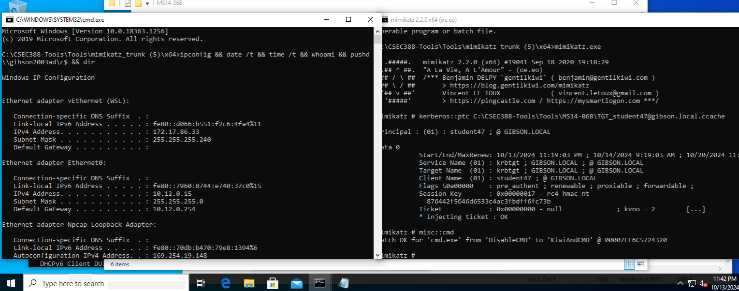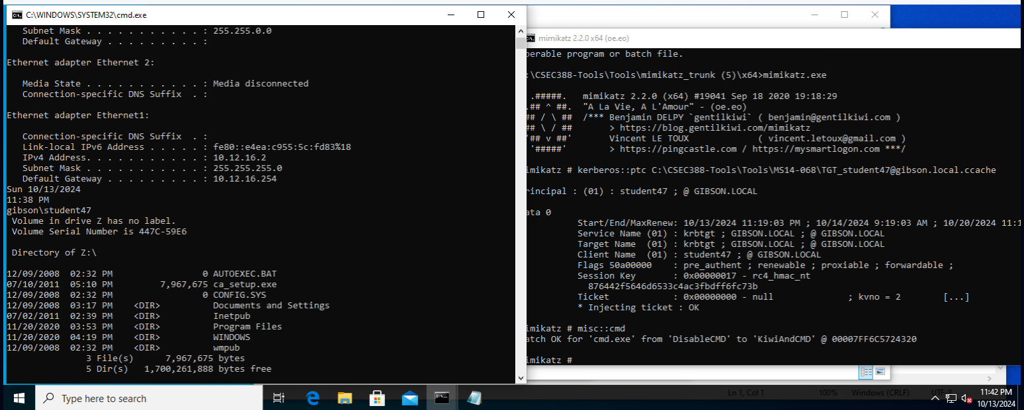

# DCSync

1. Open up CMD as a Domain Administrator (adminStudent*[your_student_#]*) (this is NOT student). Navigate to your x64 version of mimikatz.exe and run it.
   1. Elevate to a system level context by running token::elevate
   2. Run the command lsadump::dcsync /user:administrator and screenshot your command and results.
2. **Include screenshots asked for above. What is the output of the command? How could this be useful. (7.5 pts)**

**Answer:**

**The output of the command is the administrators NTLM hashes and LM hashes. Also listed is the SAM Account information and some Kerberos salt information. The last screenshot shows the WDigest hashes (29 total).**

**This information can be useful because you can take all of this hash information and use tools like hashcat or John the ripper to crack them. Also, in the first 2 screenshots, this information is also useful because some of these cracking tools required some of the NTLM/LM hashes and having this data will be valuable as well.**

**See Screenshots below (multiple due to long result of command)**

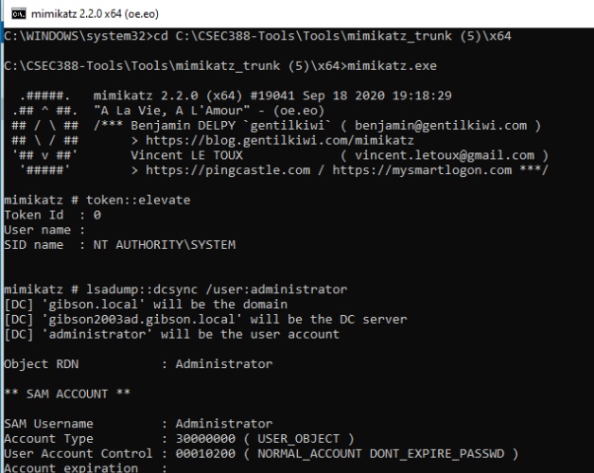

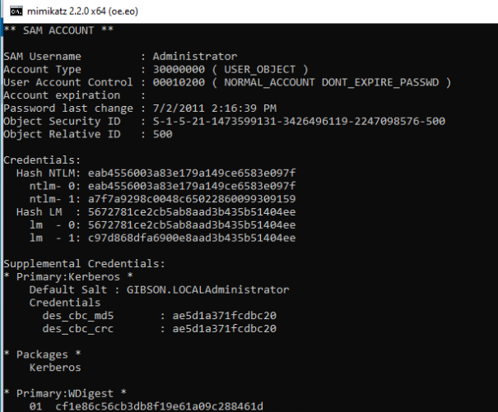

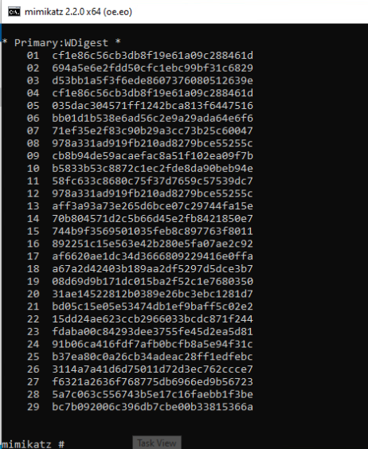

# Skeleton Key

1. Research the skeleton key attack. Use mimikatz on your 2003 AD server to perform this attack. Login with the “skeleton key” on your windows 10 box. Take a screenshot showing the commands run in mimikatz as well as a screenshot of you running the following command from your Windows 10 box from the gibson\student*#* domain account: whoami && net use y: \\gibson2003ad\c$ /user:GIBSON\adminStudent*[your_student_#]*  *your_skeleton_key_password* && dir y:

*Note: You will need to figure out how to get the mimikatz executable to the 2003 server. You can login to the 2003 server and run mimikatz from there.*

1. **How does this attack work? (7.5 pts)**
   1. **On a domaoin controller, itchanges the live ram memory of a hard drive and creates a fake password. This password (LSASS) when any computer or system tries to aunthetivate, when the password matches, it will authenticate any given account.**

**Answer:**

**This attack work by injecting the skeleton key into the LSASS file on the Windows 10 server.**

**I was going to do an SMB or RDP into the Windows 2003 AD but I gave up., I would have rather just had an internet connection on the 2003 box to download mimikatz from github.**

**Step 1: login Windows 10 box and 2003 box**

**Step 2: 2003 box is x83 so we need to use system32 version of mimikatz**

**Step 2.5**

**Step 3:**

**10.12.0.15 in internet web page in 2003 ad**

**Step 5: skeleton:: lkey**

# Bonus – Password Cracking

**BONUS) Below are a list of various hash types. Using any method you wish, attempt to crack them. Provide the tools/commands used, as well as screenshot(s) showing the flags/options used as well as the cracked hashes (clear text password).**  **Summarize the list of hashes:passwords you cracked as well. Failure to provide this, results in no bonus points given.**

**Answer 1:**

**For this one I used crackstation.net and copy and pasted the hash in the search. This is a LAN Manager hash. The hash is 32 characters.**

**23B3EFCAA559D0DBAAD3B435B51404EE = 654321**

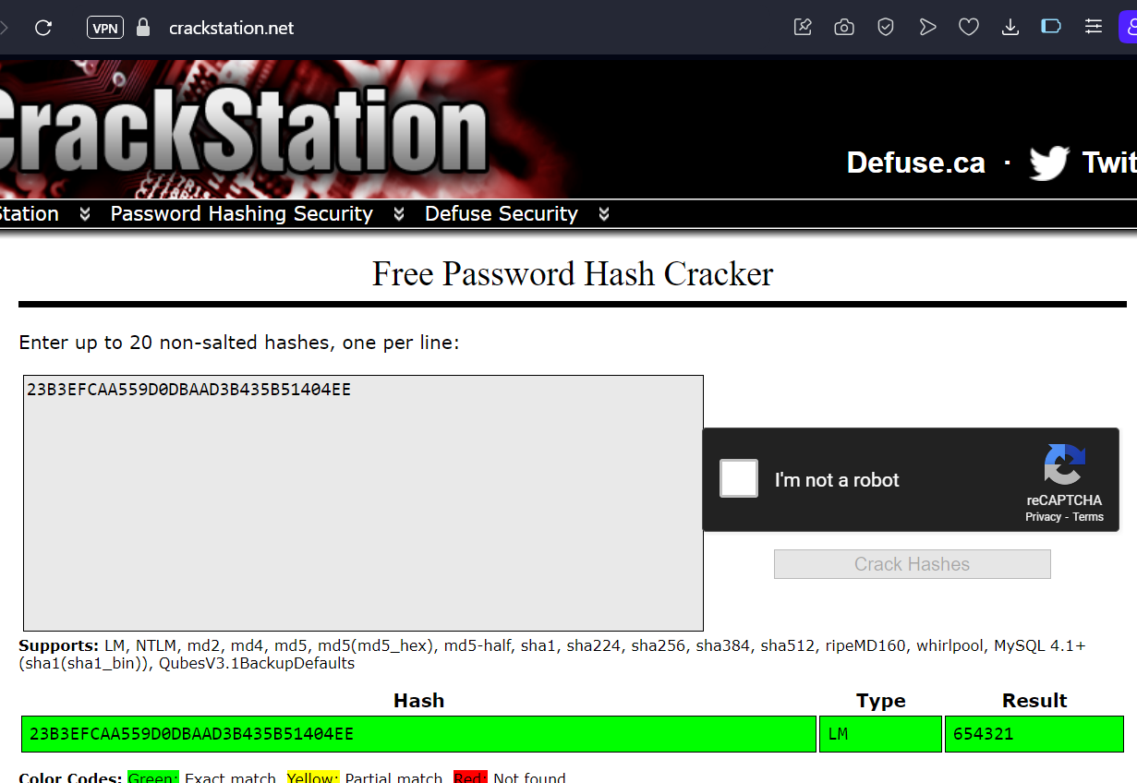

**Answer 2:**

**For this one I used crackstation.net and copy and pasted the hash in the search. This one is also a LAN MANAGER hash. The hash is 32 characters.**

**7A21990FCD3D759941E45C490F143D5F = 12345**

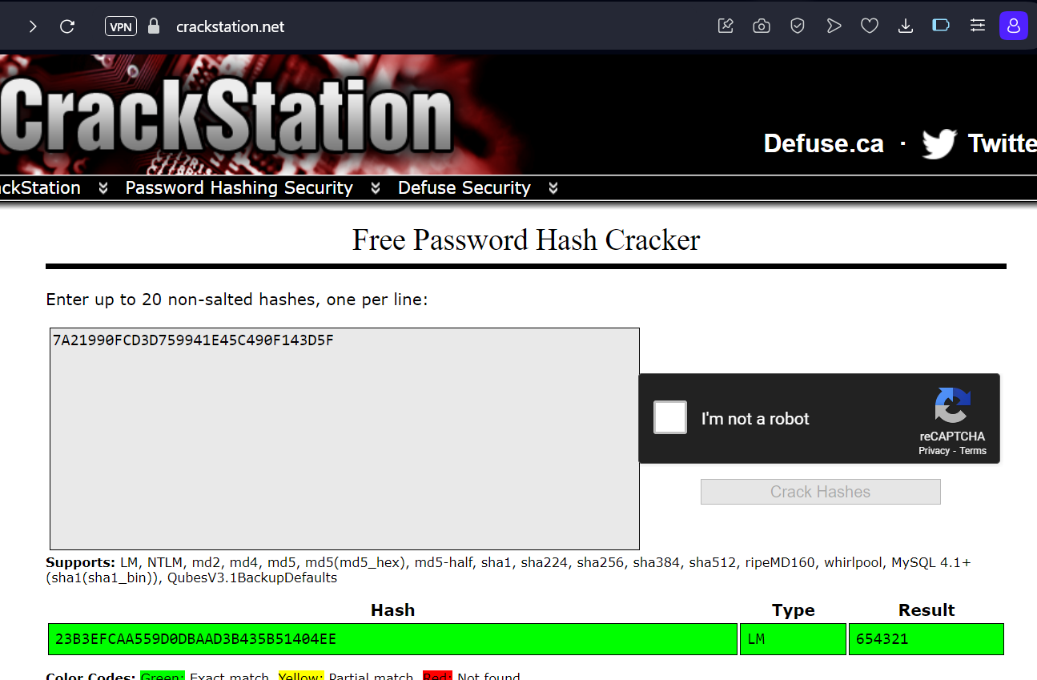

**Answer 3:**

**For this one I used hashes.com and copy and pasted the hash in the search.This hash is 32 characters is long and is also a LAN MANAGER hash.**

**674B182EB361CCBDAAD3B435B51404EE = animals**

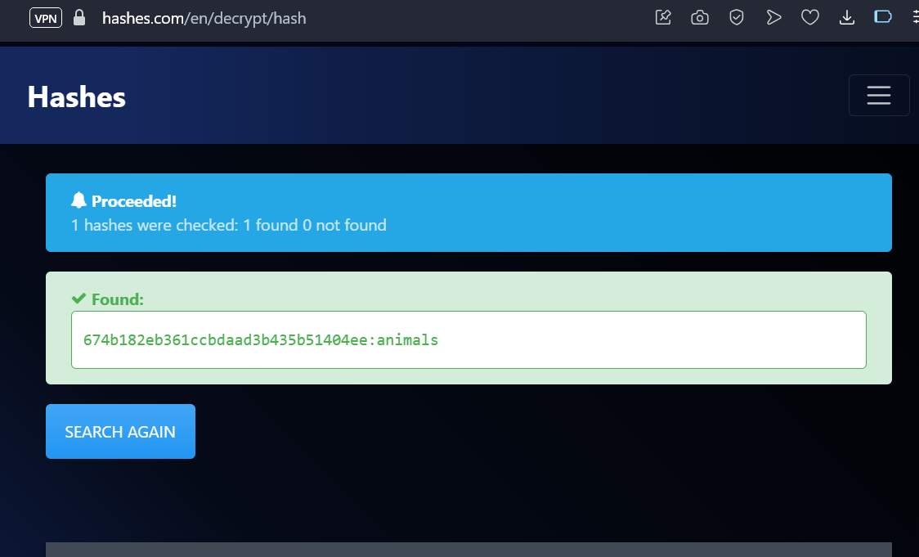

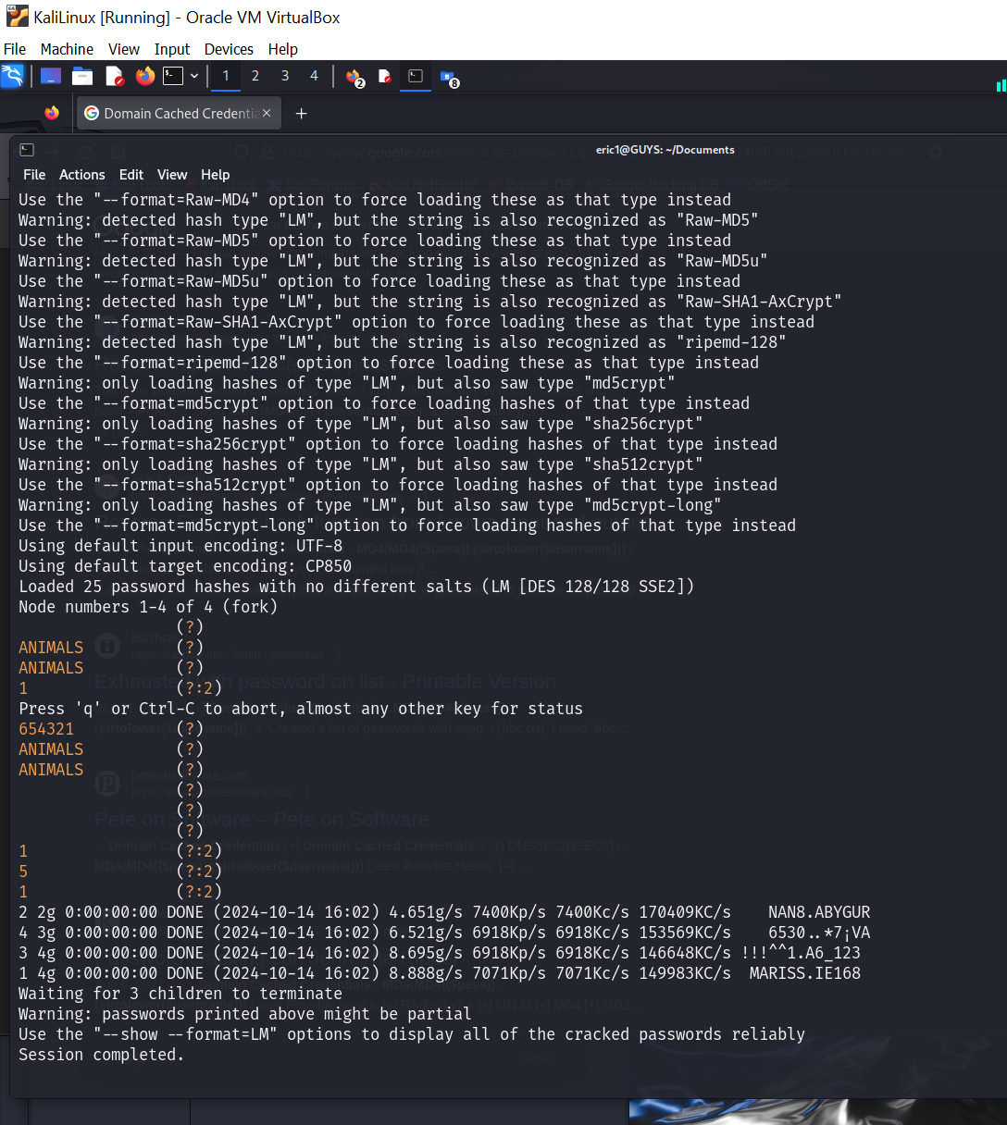

**Answer 4:**

**This hash is 32 characters and it seems to be a NTLM or MD5 hash but I ran my hash file through hashcat with this command in the screenshot and in my output.txt file it is saying the password is 0 characters. I got this result a few times.**

**31D6CFE0D16AE931B73C59D7E0C089C0 =**

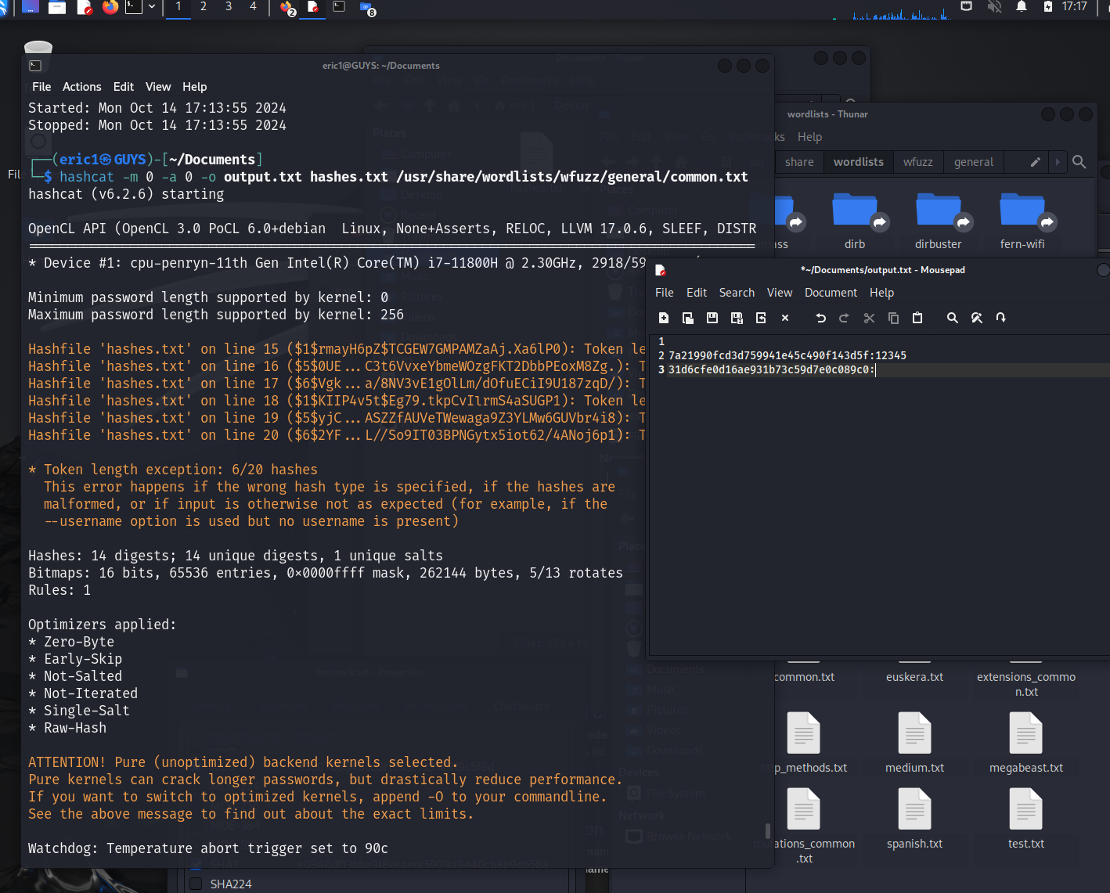

**Answer 5:**

**For this one I used hashes.com and copy and pasted the hash in the search. This hash is 32 characters and is MD5 hash. I also found fall2021 in my 2nd screenshot in my Kali Linux in the /usr/share drive.**

**174a4c22861829c9c2265b23734e0dac = fall2021**

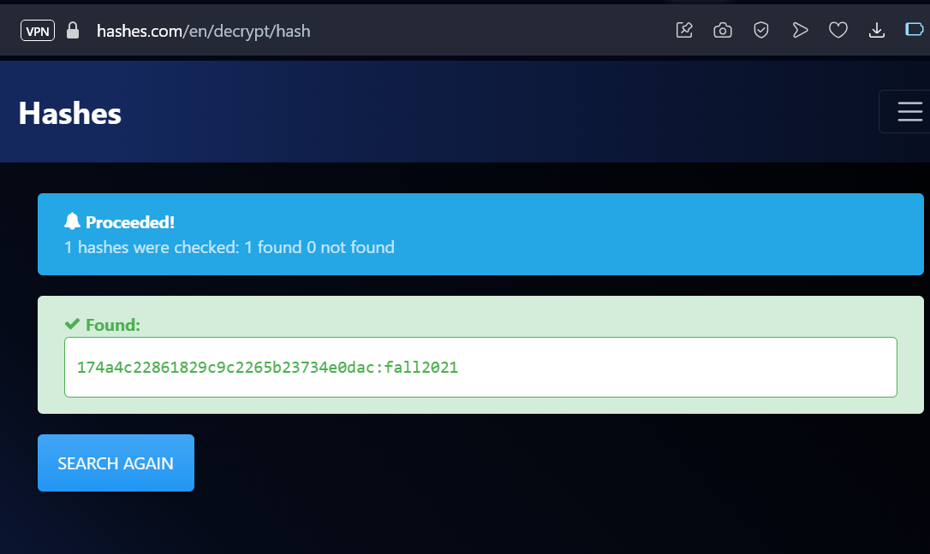

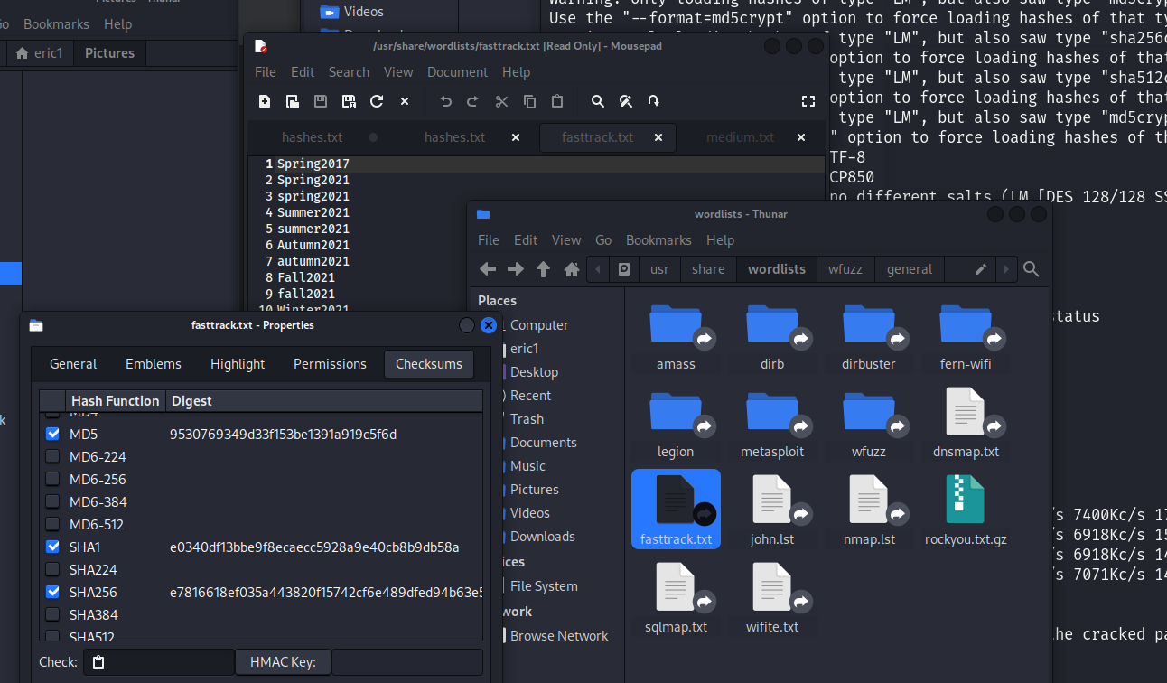

**Answer 6:**

**For this one I used hashes.com and copy and pasted the hash in the search. This is same answer as Answer #5 where the hash is 32 hexadecimal characters and is also the MD5 hash type. The second screenshot is also from my Kali Linux /usr/share directory.**

**4c3879 fef394fa5dce0037c197c70841 = Winter2021**

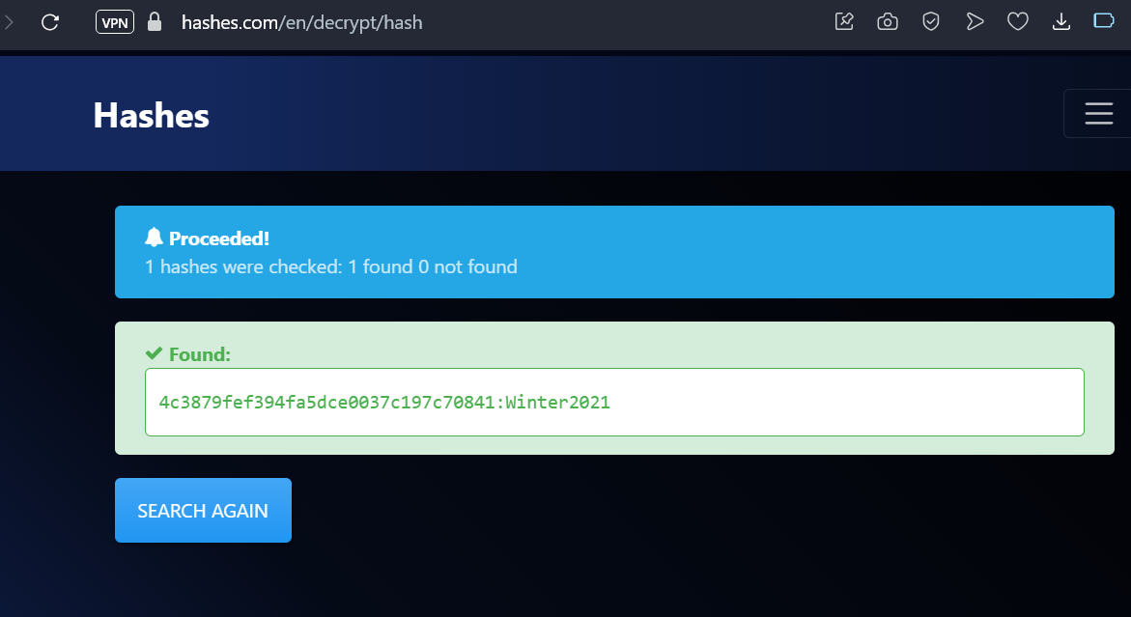

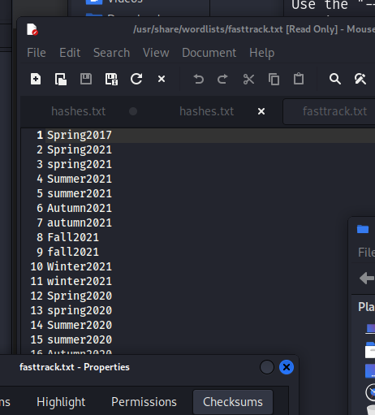

**Answer 7:**

**This hash is 32 characters long and is an NTLM hash.**

**AAD3B435B51404EEAAD3B435B51404EE =**

**Answer 8:**

**For this one I used hashes.com and copy and pasted the hash in the search. This hash is 32 hexadecimal characters long and is an MD5 hash.**

**0D719285D17BE1AD7F674595BA10AB49 = reallylongsecret**

